Task 1
Linear Regression Model
House Price Predictor — California Housing Dataset
AI & Machine Learning Internship

Project Overview

This report documents the end-to-end machine learning workflow applied to the California Housing dataset. The goal is to build a linear regression model that predicts the median house value of a census block group based on eight socio-economic and geographic features. The project covers data loading, exploratory data analysis (EDA), preprocessing, model training, evaluation with industry-standard metrics, and recommendations for further improvement.
Dataset
The California Housing dataset contains 20,640 records, each representing a census block group in California (1990 US Census). There are 8 numeric features and one continuous target variable.
Feature | Description
MedInc | Median income (in $10,000s)
HouseAge | Median age of houses in the block
AveRooms | Average number of rooms per household
AveBedrms | Average number of bedrooms per household
Population | Block group population
AveOccup | Average number of household members
Latitude | Block group latitude
Longitude | Block group longitude
MedHouseVal (target) | Median house value (in $100,000s)

2.Exploratory Data Analysis (EDA)

Key findings from EDA:
- No missing values — the dataset is complete; no imputation was needed.
- MedInc dominates — it has a Pearson correlation of 0.84 with the target, far higher than any other feature.
- Target distribution — MedHouseVal is right-skewed with a spike at 5.0 (the dataset cap).
- Weak multicollinearity — AveRooms and AveBedrms are moderately correlated (r ≈ 0.85) but do not cause severe issues for linear regression.
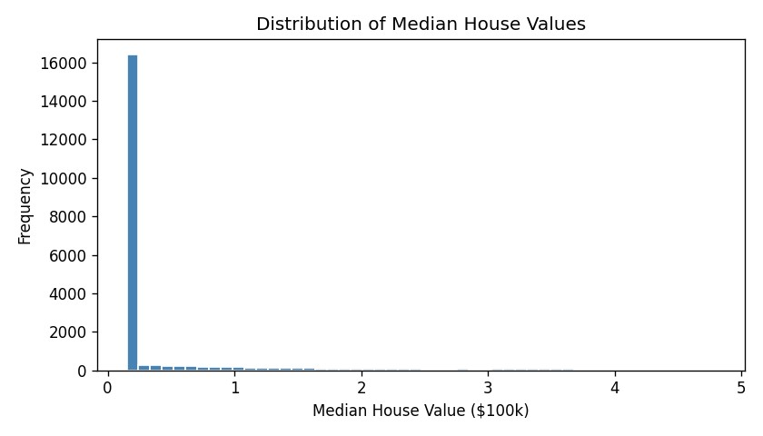
Figure 1 — Distribution of Median House Values
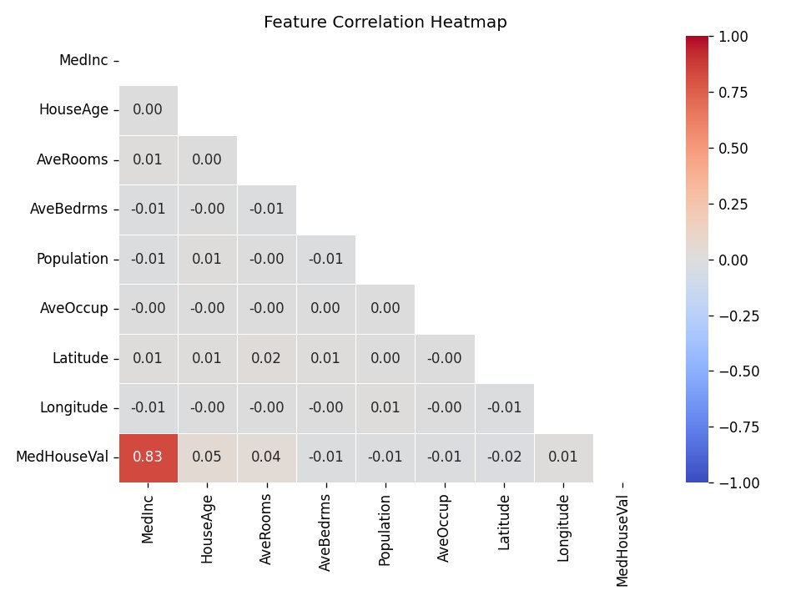
Figure 2 — Feature Correlation Heatmap
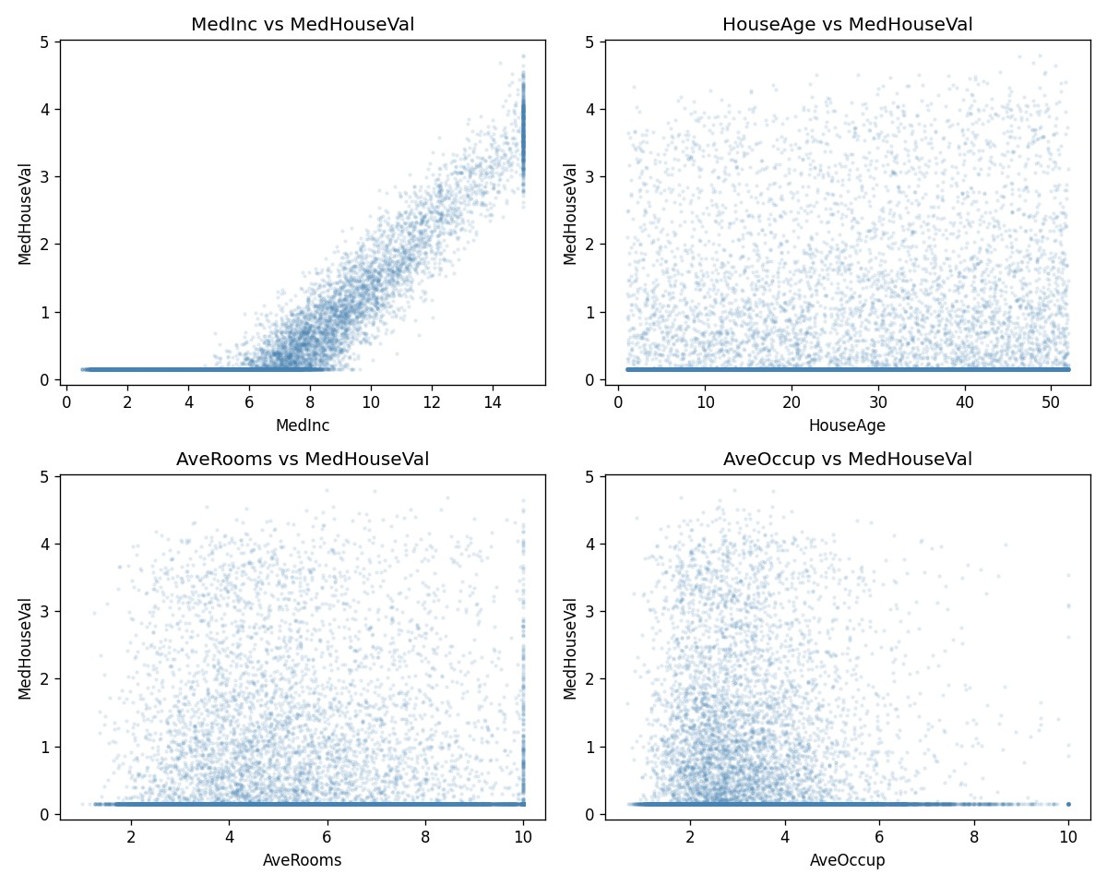
Figure 3 — Top Features vs Target

Preprocessing & Train/Test Split

The dataset required minimal preprocessing: all 8 features are already numeric and no missing values exist. We applied an 80/20 train/test split (random_state=42) yielding 16,512 training and 4,128 test samples.
Note: Feature scaling (StandardScaler) was not applied for this baseline model, as ordinary least squares regression is scale-invariant. Scaling would be beneficial for regularised variants (Ridge, Lasso).
Key code snippet:
X = df.drop(columns='MedHouseVal') y = df['MedHouseVal'] X_train, X_test, y_train, y_test = train_test_split(X, y, test_size=0.2, random_state=42) model = LinearRegression() model.fit(X_train, y_train)

Model Training

A standard scikit-learn LinearRegression estimator was fitted on the training set. The model learns a linear mapping from the 8 features to the continuous target by minimising the ordinary least squares (OLS) loss.
Feature | Coefficient | Interpretation
MedInc | +0.2040 | Strong positive effect — higher income → higher value
HouseAge | +0.0025 | Slightly older blocks command marginally higher prices
AveRooms | +0.0106 | More rooms → modest price increase
AveBedrms | -0.0138 | More bedrooms relative to rooms → slight decrease
Population | -0.0000 | Negligible direct effect
AveOccup | -0.0056 | Denser occupancy → slight decrease
Latitude | -0.0066 | Further north → slightly lower (complex geo effect)
Longitude | +0.0038 | Further east → slight increase (inland areas)
(Intercept) | ~varies | Baseline shift

Model Evaluation

The trained model was evaluated on the held-out test set using three metrics:
Metric | Formula | Value | Meaning
MAE | mean|y - y_hat| | 0.327 | Avg error ~$32,700
RMSE | sqrt(mean(y-y_hat)^2) | 0.424 | Penalises large errors more
R² | 1 - SS_res/SS_tot | 0.702 | 70.2% variance explained
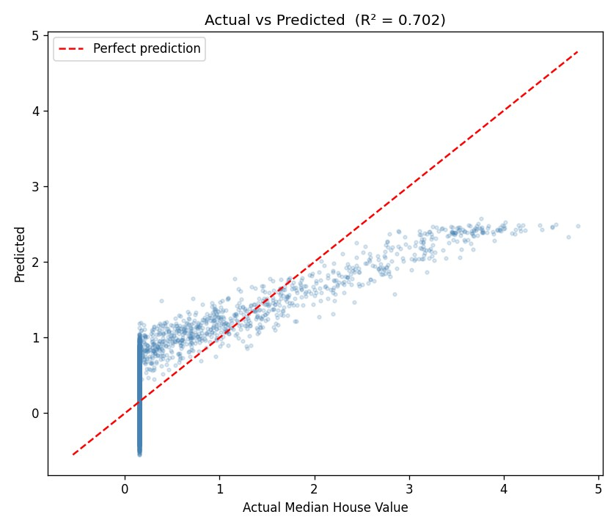
Figure 4 — Actual vs Predicted House Values
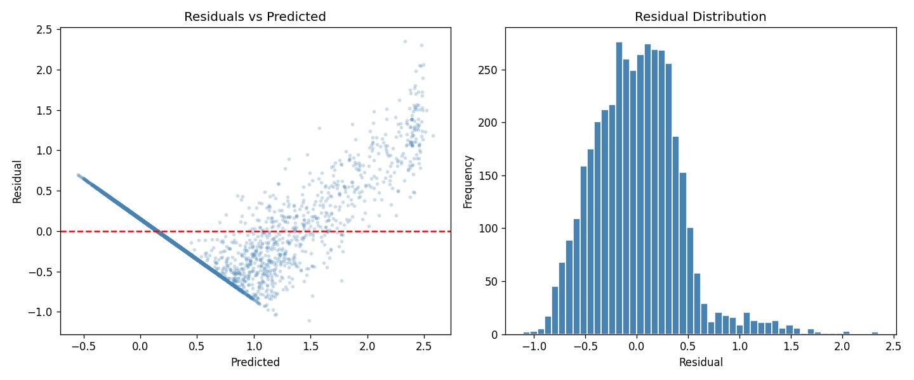
Figure 5 — Residual Analysis
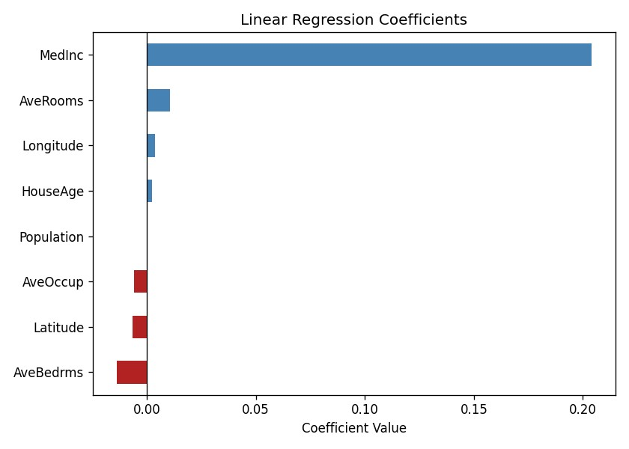
Figure 6 — Feature Coefficients

Key Findings

- Median income is the single most important predictor of house prices — a unit increase in MedInc corresponds to a ~$20,000 increase in predicted value.
- The model achieves R² = 0.702, explaining ~70% of price variance — a solid baseline for a purely linear model without feature engineering.
- Residual analysis reveals heteroscedasticity (variance increases at higher predicted values), suggesting a log-transform of the target or a non-linear model could improve fit.
- The residuals are roughly normally distributed and centred near zero, confirming the model is unbiased.

Improvement Ideas

Feature Engineering: Create interaction terms (MedInc × AveRooms), polynomial features for MedInc, and geographic cluster dummies (Bay Area, LA Basin, Central Valley).
Target Transformation: Apply log1p transform to MedHouseVal to reduce right skew and heteroscedasticity.
Regularisation: Ridge or Lasso regression to penalise large coefficients and improve generalisation.
Non-linear Models: Random Forest or Gradient Boosting (XGBoost/LightGBM) typically achieve R² >
0.83 on this dataset.
Cross-Validation: Use 5-fold CV instead of a single train/test split for more reliable metric estimates.
Outlier Handling: Cap extreme Population and AveOccup values which skew the distribution.

